PostList.js

import React, { Component } from 'react'

import axios from 'axios'

class PostList extends Component{

    constructor(props){

        super(props)

        this.state={

            posts: []

        }

    }

    componentDidMount(){

        axios.get('https://jsonplaceholder.typicode.com/posts')

        .then(response =>{

            console.log(response)

            this.setState({posts: response.data})

        })

        .catch(error=>{

            console.log(error)

        })

    }

    render(){

        const { posts }= this.state

    return (

        <div>

           List of Posts

           {

               posts.length ?

               posts.map(post => <div key={post.id}>{post.title}</div>) : null

           }

        </div>

    )

}

}

export default PostList

app.js

import React, { Component } from 'react'

import './App.css';

import PostList from './Components/PostList';

class App extends Component  {

  render(){

  return (

    <div className="App">

      <PostList />

    </div>

  );

}

}

export default App;

output

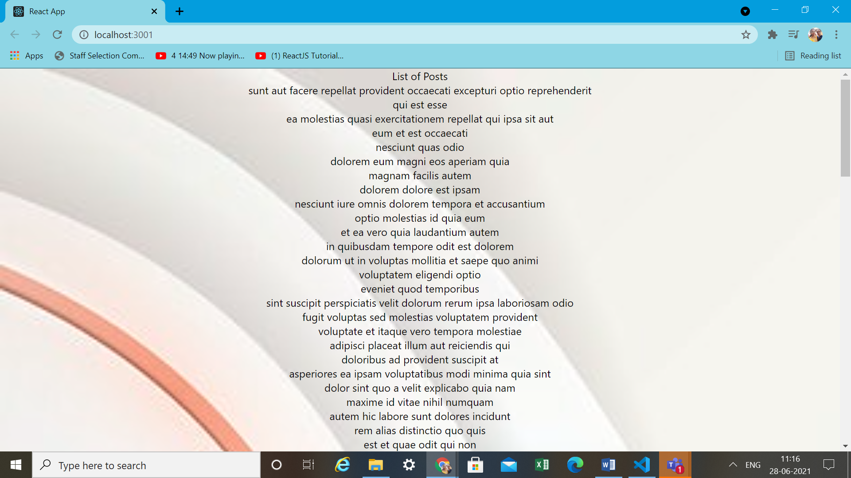

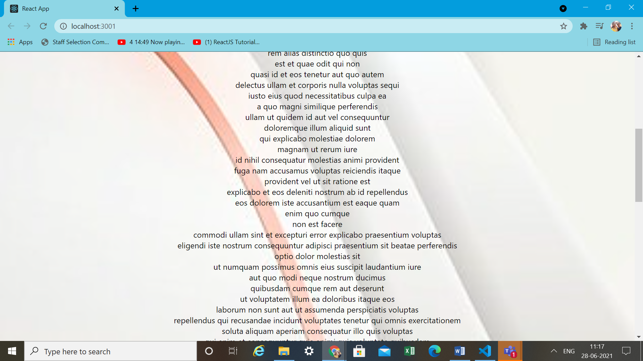

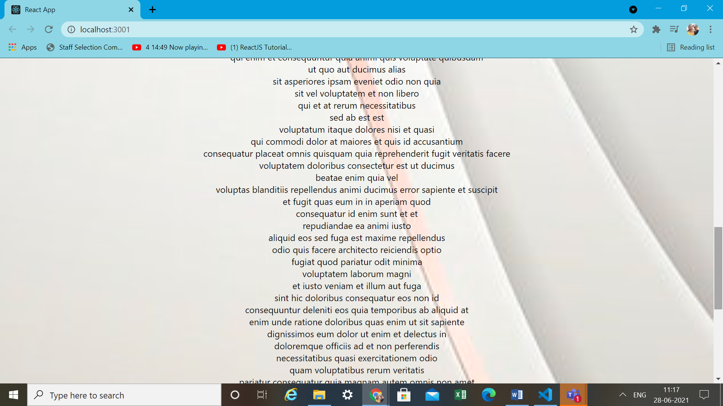

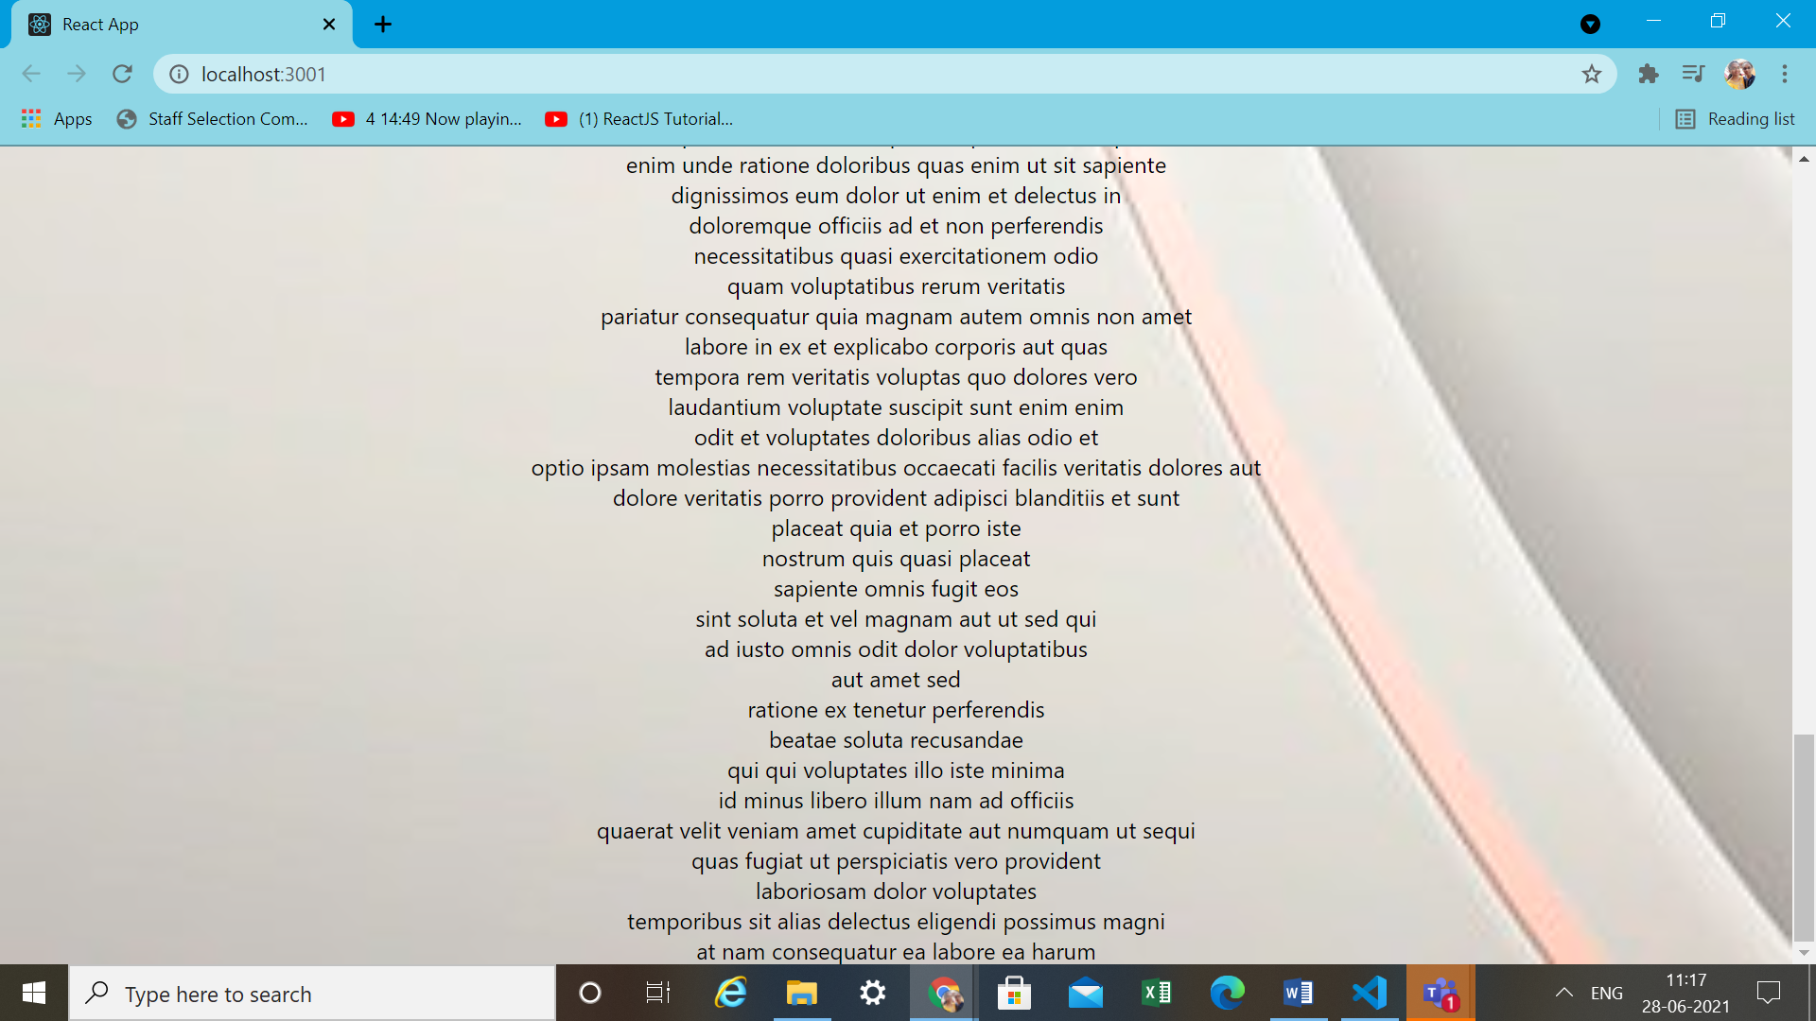

PostFormjs

import React,{ Component } from 'react'

class PostForm extends Component {

    constructor(props){

        super(props)

        this.state = {

            userId: '',

            title: '',

            body: ''

        }

    }

    changeHandler=(e) =>{

       this.setState({[e.target.name]: e.target.value})

    }

    submitHandler=e => {

       e.preventDefault()

        console.log(this.state)

    }

    render(){

        const { userId, title, body } = this.state

    return (

        <div>

          <form onSubmit={this.submitHandler}>

              <div>

                  <input type="text" name="userId" value={userId} onchange={this.changeHandler} />

                  </div>

                  <div>

                  <input type="text" name="title" value= {title} onchange={this.changeHandler} />

                  </div>

                  <div>

                  <input type="text" name="body" value={body} onchange={this.changeHandler} />

              </div>

              <button type='submit'>Submit</button>

          </form>

        </div>

    )

}

}

export default PostForm

app.js

import React, { Component } from 'react'

import './App.css';

import PostForm from './Components/PostForm';

class App extends Component  {

  render(){

  return (

    <div className="App">

      <PostForm />

      {/\*<PostList />\*/}

    </div>

  )

}

}

export default App;

output

